**Project 5**

**Real Estate Agency**

**Team name: Coders**

Mazaripov Kylymbek(55469). Tynarbekov Turarbek(55460)

**Introduction**

Program saves properties shows it. It also can search according to given filters.

**Photos**



1. Main menu



1. Data to show, next button enabled, checkboxes disabled.





1. Add New Property form



d)filter result based on the price



d)filter result based on rooms



e)filter result based on contract type

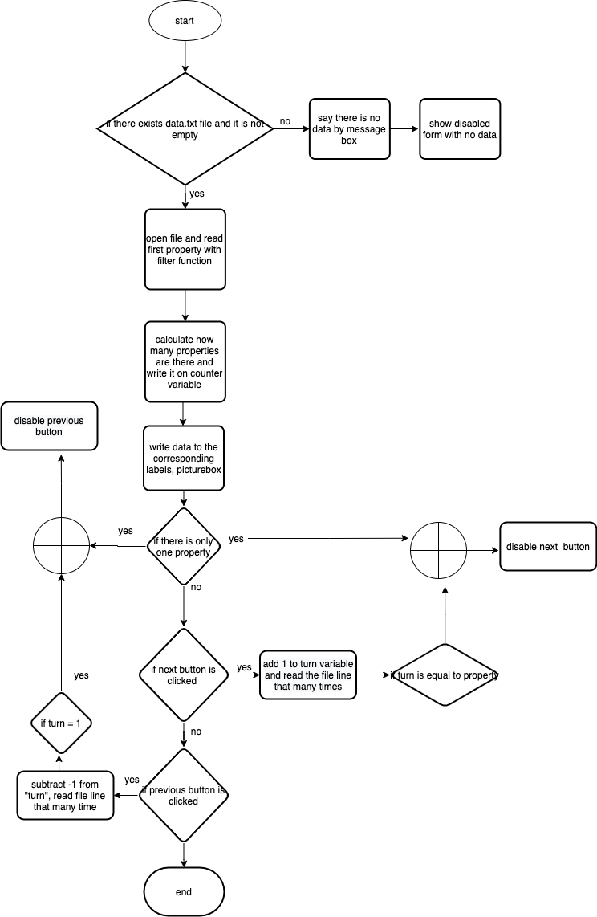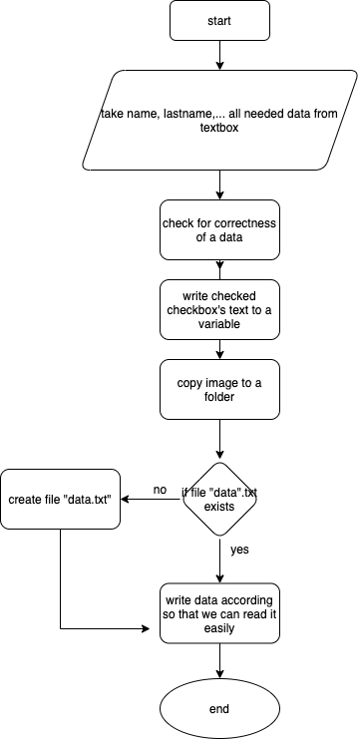

Show properties flowchart

Save properties flowchart

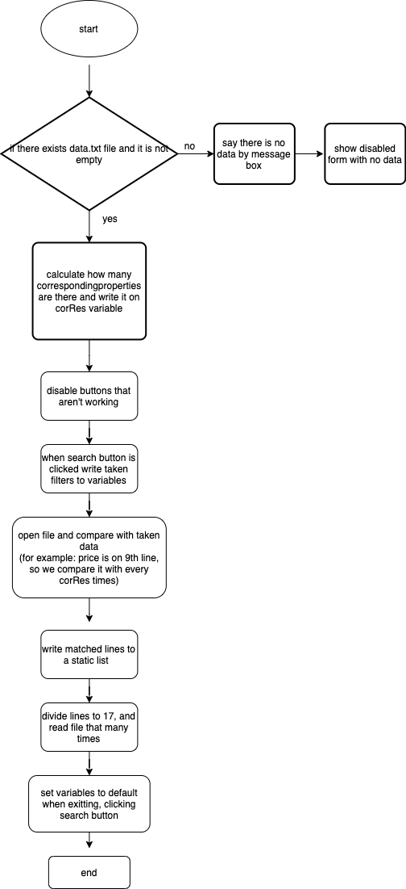

Search property flowchart